**Sprint 1 Plan**

**Product:** GoLift

**Team Name:** Team Squat Squad

**Release Name:** Release 1

**Sprint Completion Date:** July 9

Revision Two

**Revision Date:** July 12

**Goal:** Design layout for the app, implement account creation and login functionality, and decide on the app functionality

**Tasks:**

*As a new user of technology, I would like an app that is user friendly*

Make an app that can manage accounts (2 hours)

Make an app that can take in and save user information (3 hours)

Design layout of app (2 hours)

*As someone starting to workout, I would like to know more about my body type*

Research on diet plans and workout plans (1 points)

Make a quiz that determines between the three body types (2 points)

**Team Roles:**

Merrick Swaffar: (Product Manager)

Nishika Tripathi: (Scrum Master)

Siobhán O’Shea: (Scrum Master)

Jenna Wu: (Team - designer)

Peyton Fonck: (Team - developer)

**Initial Task Assignment:**

Merrick Swaffar: *As a new user of technology, I would like an app that is user friendly,* Make an app that can manage accounts (2 points) Make an app that can take in and save user information (3 hours)

Nishika Tripathi: *As someone starting to workout, I would like to know more about my body type,* Research on diet plans and workout plans (1 points), Make a quiz that determines between the three body types (2 points)

Siobhán O’Shea: *As someone starting to workout, I would like to know more about my body type,* Research on diet plans and workout plans (1 points), Make a quiz that determines between the three body types (2 points)

Jenna Wu: *As a new user of technology, I would like an app that is user friendly,* Design layout of app (2 hours)

Peyton Fonck: *As a new user of technology, I would like an app that is user friendly,* Design layout of app (2 hours)

**Initial Burnup Chart:**

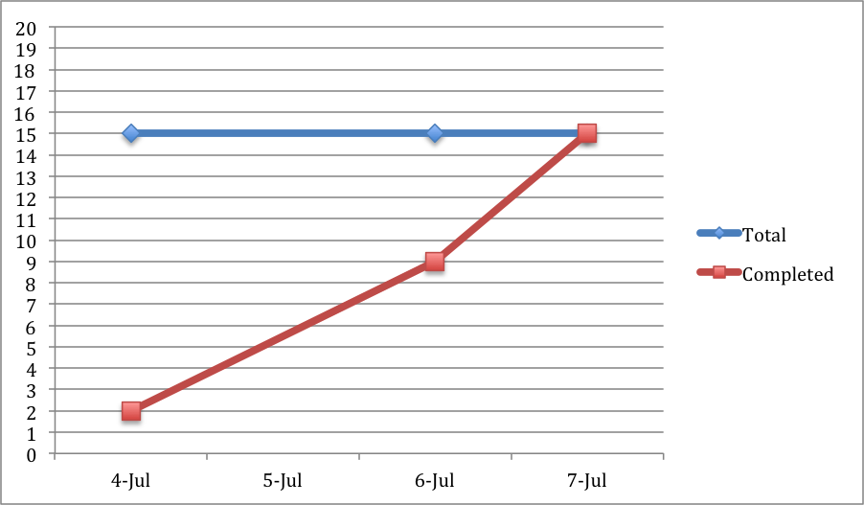

**Updated Scrum Board**

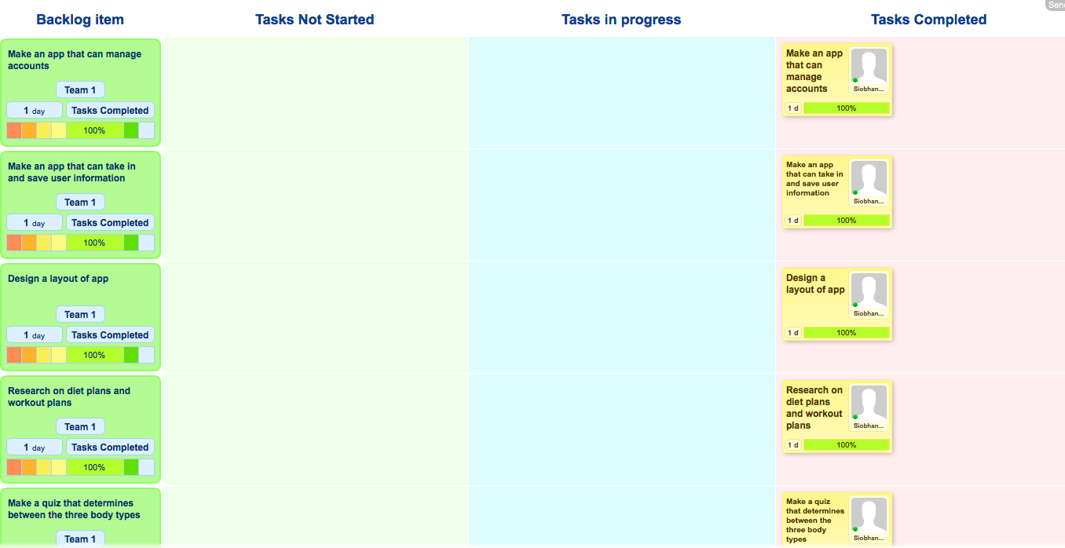

**Scrum Times**

Monday 4:30

Wednesday 4:30

Thursday 12:30